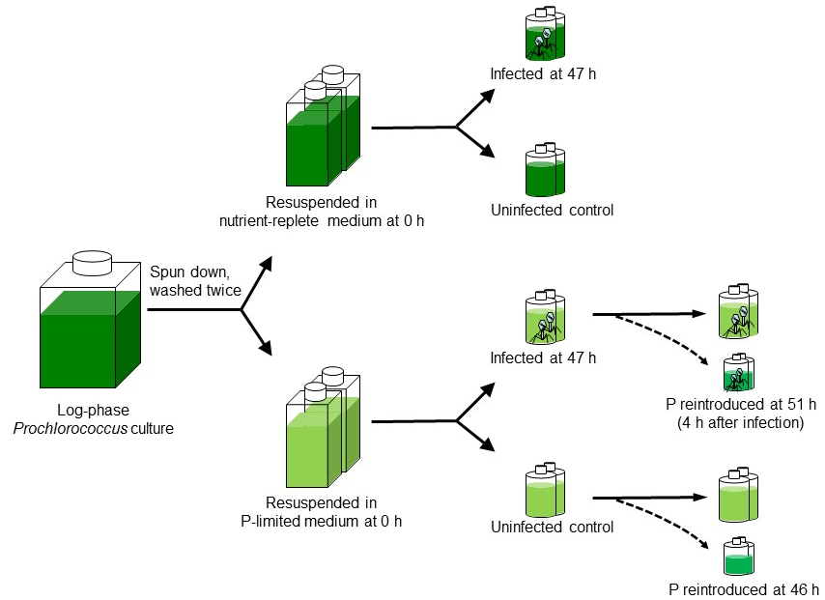

Figure S1. Experimental design
Log phase Prochlorococcus NATL2A cells were pelleted by centrifugation and resuspended in nutrient-replete (control) or P-limited (-P) media. After 47 hours of growth, aliquots from both nutrient-replete and P-limited cultures were infected by cyanophage P-SSM2. Phosphate (P) was reintroduced to aliquots of the P-limited uninfected and P-limited infected cultures to rescue the cells from P starvation at 46 h and 51 h, respectively.

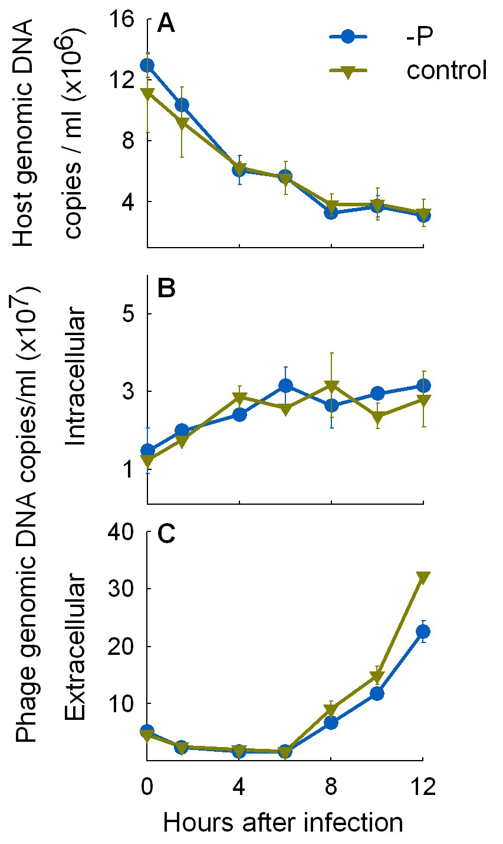

Figure S2. Infection kinetics of Prochlorococcus NATL2A by cyanophage P-SSM2 under nutrient-replete (control) and P-limited (-P) conditions.
A. Host genomic DNA was degraded after phage infection, measured as the disappearance of the host rnpB gene copies. B. Phage DNA replication measured as the number of intracellular phage pstS gene copies (each representing a phage genome). C. Progeny phage release measured as the number of extracellular phage pstS gene copies. Error bars indicate the s.d. from two biological replicates. When not visible they are smaller than the data points. At each time point it took 10 to 30 min to process all the samples, and therefore 0 h after infection could actually be 0.5 h after infection. Figure redrawn from Zeng and Chisholm, 2012.

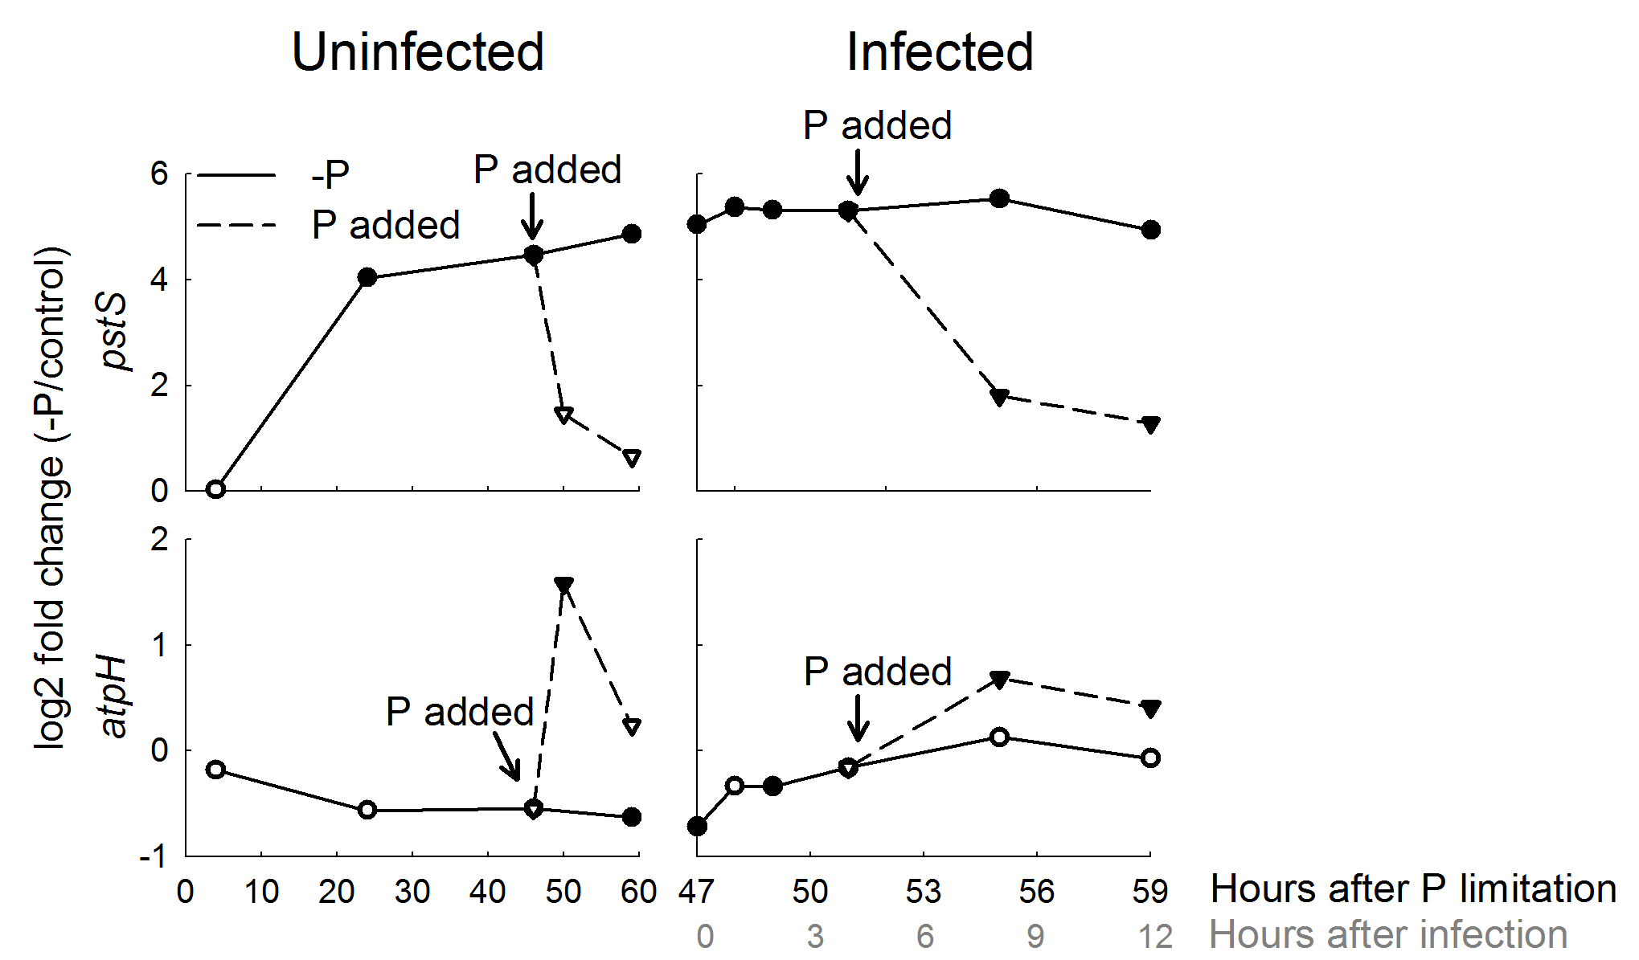
Figure S3. Plots showing Prochlorococcus NATL2A pstS and atpH transcript abundances during infection by cyanophage P-SSM2 under P-limited (-P) and nutrient-replete (control) conditions.
Relative transcript abundances of two representative host genes (pstS and atpH) from the heat map in Fig. 2 were plotted. Left panels showed transcript abundances in the uninfected cultures and right panels in the infected cultures. The cultures were infected at 47 h after P limitation, which corresponds to 0 h after infection, as shown under the x-axis of the infected plots. Solid lines showed log2 fold change (-P/control). Dashed lines showed log2 fold change (-P/control) when P was added back to the P-limited cultures. Data shown are the average of two biological replicates. Filled symbols indicate adjusted p-values < 10%.

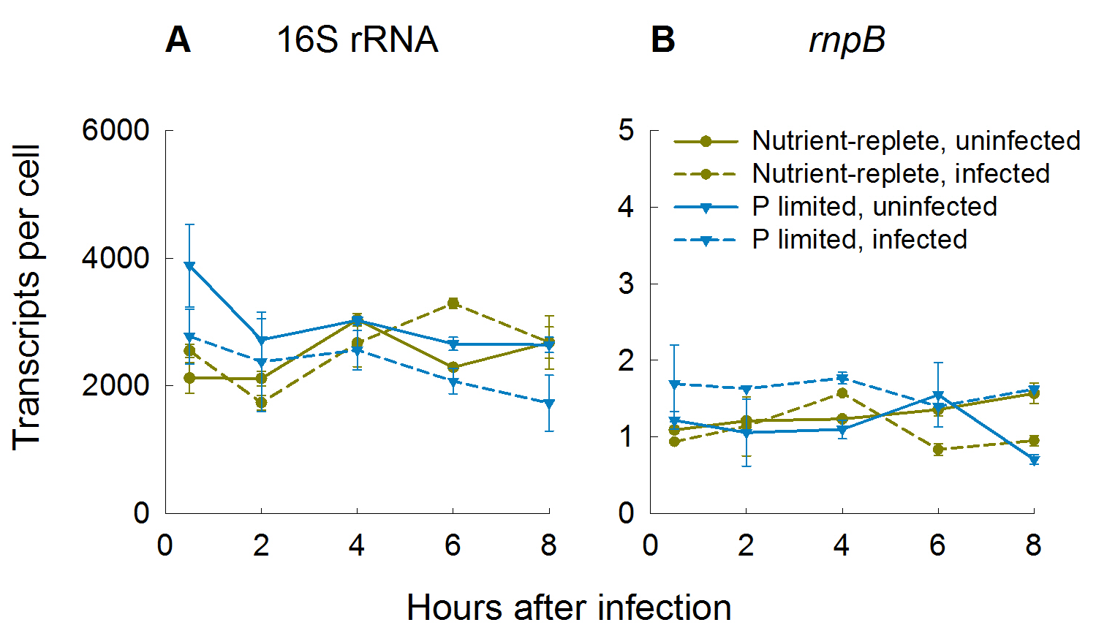

Figure S4. Transcript numbers of Prochlorococcus NATL2A under different conditions.
After growth in P-limited or nutrient-replete media for 47 hours, Prochlorococcus NATL2A was infected by cyanophage P-SSM2. The host 16S rRNA (A) and rnpB (B) transcript numbers were calculated using the spike-in internal RNA standard. Error bars indicate the standard deviation from two biological replicates. When not visible they are smaller than the data points.

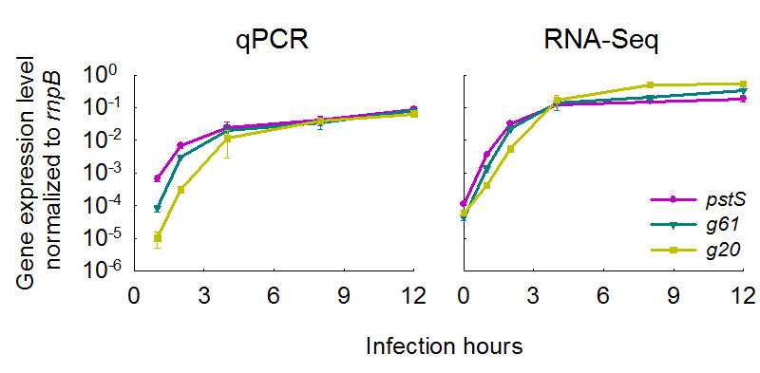

Figure S5. Verification of RNA-Seq results by qPCR.
Prochlorococcus NATL2A was infected by cyanophage P-SSM2 under nutrient-replete conditions. Transcript levels of three representative cyanophage genes (g20, g61 and pstS) were determined by qPCR (left panel) and RNA-Seq (right panel) using the same RNA samples. The host rnpB gene was used as an internal standard for both qPCR and RNA-Seq to facilitate direct comparison. The data shown are the average of two biological replicates.

Supplementary References
Zeng, Q., and Chisholm, S.W. (2012) Marine viruses exploit their host's two-component regulatory system in response to resource limitation. Curr Biol 22: 124-128.

